Applying the Principles of AIDS ‘Exceptionality’ to Global Health: Challenges for Global Health Governance

Gorik Ooms, Peter S. Hill, Rachel Hammonds, Luc Van Leemput, Yibeltal Assefa, Katabaro Miti and Wim Van Damme

In this paper, we argue that a key feature of the “exceptionality” of the global AIDS response—its reliance on open-ended international solidarity to complement domestic efforts—can only be preserved if it is extended to broader health issues of the poorest countries of the world. This reliance on open-ended international solidarity hinges on three related principles: a new approach to sustainability, a flexible application of fiscal space constraints, and an international financing mechanism that provides long term reliable assistance. We will briefly explain these principles, focusing particularly on fiscal space constraints because the importance of that element is often overlooked or underestimated. Then we will explain why health systems and broader health issues in low-income countries need the same three principles (or similar solutions), to sustain early successes of the global AIDS response and to expand these successes. Finally, we will examine the challenges the wider application of the principles of AIDS exceptionality creates for global health governance.

AIDS Exceptionality as Reliance on Open-Ended International Solidarity: Three Principles

The global AIDS response—including the provision of AIDS treatment in low-income countries—relies on open-ended international solidarity. The so-called “Harvard Consensus Statement” of April 2001 stated that “AIDS treatment will always be more expensive than poor countries can afford, meaning that international aid is key to financing the effort”. More recently, Hecht and colleagues estimated the cost of different scenarios for the global AIDS response from 2009 until 2031 and concluded that “low-income countries with a high burden of disease will remain reliant upon external support for their rapidly expanding costs”. As we become accustomed to the reality of AIDS treatment being provided in low-income countries—albeit at an insufficient level to meet the needs—we may overlook how the provision of AIDS treatment in low-income countries is fundamentally exceptional. To avoid misunderstandings: this element of AIDS exceptionality is different from the original meaning of “HIV exceptionalism”, i.e. the non-application of public health measures like mandatory testing, screening and case reporting because of the discrimination and stigmatization of people living with HIV. AIDS exceptionality discussed here—a reliance on open-ended international solidarity—is composed of three related principles.
First, AIDS exceptionality required a new approach to sustainability. As Kazatchkine, the Executive Director of the Global Fund to fight AIDS, Tuberculosis and Malaria (Global Fund) summarized it: “The Global Fund has helped to change the development paradigm by introducing a new concept of sustainability; one that is not based solely on achieving domestic self-reliance, but on sustained international support, as well.” In reality, however, this new approach to sustainability is not shared by all involved in global health. The World Health Report 2008, for example, mentions that funds like those provided by the Global Fund “need to be progressively re-channelled in ways that help build institutional capacity towards a longer-term goal of self-sustaining, universal coverage” (emphasis added). This goal of self-sustainment would undermine the global AIDS response: the package of health goods and services that even the poorest countries can afford to provide would not include what it takes to fight AIDS.Error: Reference source not found Second, AIDS exceptionality required a flexible application of fiscal space constraints. In his November 2003 lecture at the World Bank, Piot, then Executive Director of UNAIDS, articulated this element in the following comment: “when I hear that countries are choosing to comply with medium-term expenditure ceilings at the expense of adequately funding AIDS programs, it strikes me that someone isn’t looking hard enough for sound alternatives.” Piot added: “For countries emerging from conflict, the Bank has pioneered a careful program of exceptions, running a calculated risk on the grounds that inaction would be riskier still. Let us now do something similar for AIDS, a risk far greater than conflict for many countries.”Error: Reference source not found The careful program of exceptions Piot referred to is about rules and norms for public health expenditure used by the World Bank and the International Monetary Fund (IMF) in developing countries, which seem to be more flexible for countries emerging from conflict than for so-called ‘stable’ countries, and which are often referred to as fiscal space constraints.
Fiscal space refers to the ability of a country to sustain its health (or other) expenditure through future domestic revenue. This is illustrated below by figure 1, adapted from a background paper by Hay and Williams for a meeting of the High Level Forum on the Health Millennium Development Goals.

Figure 1: Fiscal space

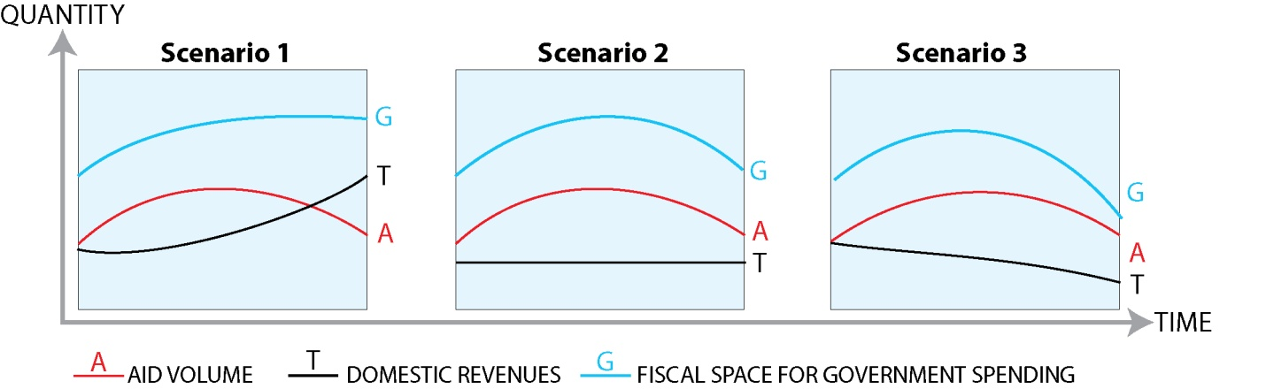

Fiscal space (the G-curve) is nothing more than the sum of available financing: domestic revenue (the T-curve) and assistance (the A-curve). However, fiscal space is often used as a synonym for fiscal sustainability. To explain this, we added a few data to the second scenario, in figure 2.

Figure 2: Fiscal space and the sustainability problem

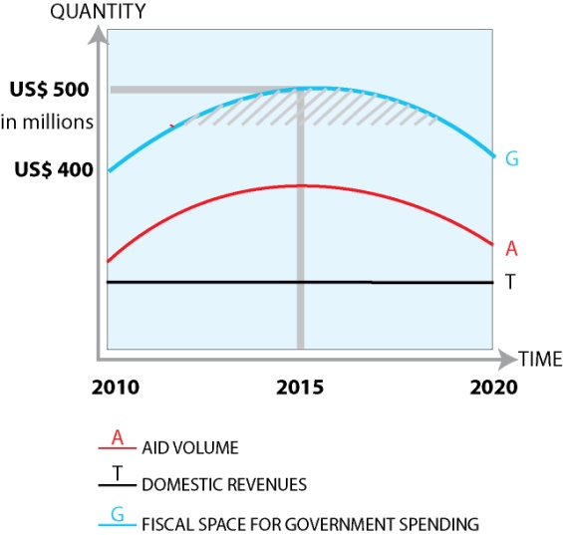

Consider a hypothetical country with a health sector budget of US $400 million in 2010, of which US $180 million is domestic revenue, and US $220 million is external assistance. Assistance is expected to increase to US $320 million by 2015, while domestic revenue is expected to remain stable: fiscal space in 2015 will be US $500 million. By 2020, assistance is expected to decrease to its 2010 level, and fiscal space will again be US$400 million. The shaded area in figure 2 is problematic: it represents fiscal space, but unsustainable fiscal space. It could be used for investments, but it would be problematic to use it for recurrent costs, like salaries of additional health workers, or purchases of medicines newly added to the national list of essential medicines. Indeed, if the assumptions are correct, by 2020 financing for salaries for those additional health workers would no longer be available, and the list of essential medicines would have to be reduced.
That problem would be solved if we can assume that external assistance to our hypothetical country will not decrease after 2015: the fiscal space at US$500 million would then be sustainable. Figure 3 illustrates this.

Figure 3: Fiscal space and the sustainability problem resolved

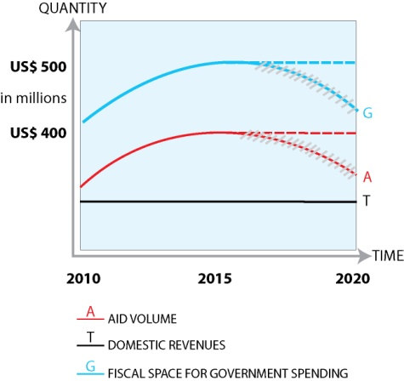

As Sarbib and Heller on behalf of the World Bank and the IMF replied to a paper co-authored by one of us: “Make more aid reliably available, and more long-term programs will be possible” (emphasis added).
That brings us to the third principle: long term reliable external assistance. In its guidelines for proposals, the Global Fund assures that “[a]pplicants are not required to demonstrate financial self-sufficiency for the targeted interventions by the end of the proposal term” (emphasis in original). The implicit commitment is that the Global Fund will continue to finance those interventions, as long as needed. Can it live up to this commitment? The Global Fund itself relies on contributions from richer countries. The most recent replenishment round of the Global Fund was disappointing, but represents nonetheless “the largest sum ever mobilized for global health”. So far, it looks as if the Global Fund will be able to honor its earlier commitments, albeit without being able to make substantial new ones.

Applying the principles of AIDS exceptionality to global health: three arguments

Our first argument for applying the principles of AIDS exceptionality to health exceptionality is that universal access to AIDS prevention and treatment requires stronger health systems in developing countries. Whiteside observes: “Treatment is still not universally accessible, nor will it be. With the current drugs and modes of administering them, there are simply not the human resources and infrastructure to provide treatment to all.” Ruxin compared the first wave of AIDS treatment in low-income countries with low-hanging fruit: “You quickly reach a point where you can’t treat more people unless you develop the national health systems”.
The Taskforce on Innovative International Financing for Health Systems estimated that “Spending on health in low-income countries needs to be raised from an estimated US$31 billion today to US$67-76 billion per year by 2015.” According to World Bank estimates, one billion people live in countries classified as low-income, and their combined Gross Domestic Product (GDP) is US$565 billion. If these countries could afford to spend 3% of their GDP on health—which is an ambitious target, requiring the increase of government revenue to 20% of GDP, and allocating 15% of government revenue to health expenditure—it would provide only about US$18 billion; US$49-56 billion would have to come from external assistance. Not only would international assistance for health have to increase substantially, it would also have to be channeled in a way that is reliable enough to claim the same flexibility of fiscal space norms as for the AIDS response. As much as AIDS treatment requires open-ended reliance on international solidarity, strengthening health systems does too.
Our second argument is that AIDS exceptionality, if left unexpanded to broader health issues, will not resist the pressure from arguments that the global AIDS response is capturing a disproportionate share of international assistance. The standard reply from people involved in the global AIDS response is that richer countries should “assume more responsibility in supporting countries’ [Primary Health Care], in addition to funding treatment and care for HIV, TB, and malaria” and that “[i]t should be recognized that global action for health is even more underfunded than is the response to the HIV epidemic.” While we support this reply, we argue that more assistance alone will not change the situation: if the three essential principles of AIDS exceptionality—a new approach to sustainability, a flexible application of fiscal space constraints, and a financing mechanism able to provide assistance that is reliable in the long run—remain exceptional to the global AIDS response, more assistance for broader health issues risks being mostly useless. If sustainability remains defined as domestic financial self-reliance, low-income countries already relying on international assistance for a substantial share of their public health expenditure should not receive more assistance. If the additional assistance for broader health issues is not reliable in the long run, it is unlikely that the World Bank and the IMF will apply fiscal space constraints in a more flexible manner. In the absence of a pooling mechanism for additional assistance for broader health issues—something like the Global Fund, with a broader mandate—it will be difficult to provide a long term perspective to this assistance.
Our third argument is that the practice of providing AIDS treatment to people living in low-income countries requires a more explicit and consistent commitment from the international community (to remain reliable in the long run), and that we find it hard to imagine such an approach that singles out one disease. AIDS exceptionality—reliance on open-ended international solidarity—emerged as a pragmatic response to an unprecedented global health crisis. A combination of factors—one could call it an ‘alignment of the stars’—prompted richer countries into doing something they had never done before: co-financing a level of health care in countries that were unlikely to become able to finance such expensive health care from domestic resources. One explanation why that happened is that the global AIDS response is rooted in a human rights approach, or a right to health approach. In the early 1990s, given the absence of effective AIDS treatment, demanding that governments respect, protect and fulfill the human rights of people living with HIV was one of the few available interventions. The effectiveness of this human rights based approach evolved into an understanding that enhancing the human rights of people at higher risk of HIV infection could itself be an effective prevention strategy. A further expansion of this human rights-based thinking occurred when Brazil invoked the right to health to justify its production of generic antiretroviral medicines. This step presaged the ‘International Guidelines on HIV/AIDS and Human Rights’ issued by UNAIDS and the Office of the United Nations High Commissioner on Human Rights, which mentions that “States should ensure that international and bilateral mechanisms for financing responses to HIV/AIDS provide funds for prevention, treatment, care and support, including the purchase of antiretroviral and other medicines, diagnostics and related technologies.” Framed as a human right, AIDS treatment entails both national and international obligations, and justifies reliance on open-ended international solidarity.
It would, however, be a mistake to believe that framing AIDS treatment as a human right was the main or only factor that paved the way for AIDS exceptionality. Piot’s comparison between countries affected by AIDS and countries emerging from conflict, mentioned above, contains an allusion to the fear that AIDS constituted a security issue, a fear that was widely shared at that time.Error: Reference source not found This is no longer the case. As de Waal writes: “the macro-level fears were largely misplaced, the fear was real, and the actions taken accordingly have had consequences.” Although he cautions the international community that it would be a mistake to “discount the importance of HIV/AIDS, conflict and security”, policy makers are no longer likely to weigh the security risks of AIDS heavily in their financial allocations and prioritizations. With the ‘AIDS is a security threat’ argument eroding, the right to health argument might be the only one that can preserve AIDS exceptionality—i.e. open-ended reliance on international solidarity. The right to health argument, however, cannot justify the exceptional consideration of a single disease. A more explicit and coherent commitment from the international community, based on the right to health, would include all elements of the right to health. In fact, the global AIDS response should never have been exceptional—although it was and still is; the principles on which it is based should have been the norm for global health.

Crossroads and challenges for global health governance

In March 2001, Bellamy, then Executive Director of UNICEF, proposed that UNICEF host the Global Fund—which was being created at that time. Her main argument was that UNICEF had a global supply centre in Copenhagen that would be perfect to purchase and distribute antiretroviral medicines all over the world. It illustrates how, at that time, the Global Fund was considered by some as a tool to provide medical commodities, a vision based on the idea that the new funding mechanism was first and foremost a response to the high price of antiretroviral medicines. AIDS exceptionality, in this vision, would be limited to the long term supply of medicines, while governments and conventional international assistance streams would take care of all the other costs. The financial constraints presently facing the Global Fund may resuscitate this vision. With US$4 billion a year, the Global Fund can purchase antiretroviral medicines for 40 million people. This would end the critiques that the Global Fund is not being ambitious enough on AIDS treatment targets, or not determined enough on health systems strengthening,., A “division of labor”, as the former Executive Director of the Global Fund, Feachem, was willing to accept, keeping “rapid scale-up of disease-specific programs for the Global Fund and long-term development of fundamental health infrastructure for the World Bank”, would allow the Global Fund to respond that health systems strengthening simply is not its job.
The unlimited provision of antiretroviral medicines would not guarantee that people living with AIDS receive the medicines they need. Health systems constraints in low-income countries, including shortage of health workers, would lead to medicines remaining in storages and unused.
The alternative route is what we propose here: a substantial increase of international assistance for health in a way that allows fiscal space flexibility for all health issues. As Waage and colleagues argue, “[t]o escape this dichotomy [between disease-specific programs and broader system-wide strengthening], we need to move the debate beyond the financial sustainability of individual countries’ health budgets. Sustainability has to be linked to global obligation and solidarity that allows rational planning with the assumption that funding will be predictable, reliable, and increasing every year.” This could be achieved through a Global Fund with an expanded mandate, benefiting from mandatory contributions from richer countries. However, it requires answers to some fundamental questions. What are the essential health goods and services, to be guaranteed under the right to health, for which the international community should accept a complementary responsibility? What is the minimum contribution to be demanded from all countries, even the poorest ones? How much assistance should rich countries provide, and should they share the burden between them? Each of these questions raises challenges for global health governance, in terms of agreed health financing and implementation efforts by all countries, agreed co-financing efforts by richer countries, and mechanisms to hold all countries mutually accountable. There are, however, precedents for each of these challenges. The International Health Regulations are binding norms on all countries; they impose minimum efforts all governments must make to control emerging epidemics. A similar approach should be possible to define essential health goods and services. There are international agreements under which governments commit themselves to allocate a minimum level of domestic resources to health, such as the Abuja Declaration. Arguably, this commitment could be expanded, encouraging all countries of the world to adhere to this principle. There are several precedents of agreed burden sharing of international assistance, such as for the replenishment of the International Development Association (IDA) of the World Bank; something as vital as essential health goods and services could be addressed with a similar response. With the blinkers of international assistance’s present short term approach removed, it becomes immediately possible to imagine a Global Fund for Health.
In the complex system of global health governance, what appear to be linear choices are the composites of multiple decisions by networks of stakeholders. The argument that the present state of national and international responsibilities for global health is riddled with contradictions and profoundly confusing may not be enough to obtain a rational clarification that requires binding commitments from richer and poorer countries. However, political momentum for “universal health coverage” is growing, and the World Health Report 2010 explicitly acknowledges that “increased donor flows will be necessary for most of the poorest countries for a considerable period of time”. This acknowledgment may pave the way for the application of the principles of AIDS exceptionality to global health, and universal access to AIDS treatment and prevention may be a politically more realistic endeavour as an element of universal health coverage than as an isolated, disease-specific, and exceptional effort.

Gorik Ooms is a human rights lawyer and doctor in medical sciences; researcher at the Institute of Tropical Medicine in Antwerp, Belgium; adjunct professor of law at Georgetown University in Washington D.C., U.S.A.; and former executive director of Médecins Sans Frontières Belgium.

Peter S. Hill is a public health physician and associate professor at the Australian Centre for International and Tropical Health at the University of Queensland in Australia. His research interests are in global health governance, health systems and international development, based on his extensive experience in South East Asia and the Pacific.

Rachel Hammonds is a human rights lawyer; researcher at the Institute of Tropical Medicine, Antwerp, Belgium.

Luc Van Leemput is a researcher in global health at the Institute of Tropical Medicine, Antwerp, Belgium.
Yibeltal Assefa is a medical doctor and public health specialist. He is combining his position of Director of Planning and Monitoring and Evaluation for the national multi-sectoral HIV/AIDS response in Ethiopia with research.

Katabaro Miti is a professor in politics at the University of Pretoria, South Africa.

Wim Van Damme is a professor in public health and health policy at the Institute of Tropical Medicine, Antwerp, Belgium. He has extensive field experience in various low-income countries.

This paper was developed as part the “Global Health Initiatives in Africa” research project, financed by the European Commission. (INCO-CT-2006-032371)

Individual Members of the Faculty of Harvard University. Consensus Statement on Antiretroviral Treatment for AIDS in Poor Countries, April 4, 2001. http://www.cid.harvard.edu/cidinthenews/pr/consensus_aids_therapy.pdf
Robert Hecht, John Stover, Lori Bollinger, Farzana Muhib, Kelsey Case and David de Ferranti. “Financing of HIV/AIDS programme scale-up in low-income and middle-income countries, 2009–31.” Lancet, 376(9748): 1254-1260.
Ronald Bayer. “Public Health Policy and the AIDS Epidemic: An End to HIV Exceptionalism?” New England Journal of Medicine, 324(21): 1500-1504.
Michel Kazatchkine. “Dr. Kazatchkine’s closing speech at the international AIDS conference in Mexico,” August 11, 2008. http://www.theglobalfund.org/en/pressreleases/?pr=pr_080811
World Health Organization, The World Health Report 2008: Primary Health Care—Now more than ever, World Health Organization (Geneva, Switzerland), http://www.who.int/whr/2008/whr08_en.pdf
Peter Piot. “AIDS: The Need for an Exceptional Response to an Unprecedented Crisis. A Presidential Fellows Lecture” (presented at the World Bank, November 20, 2003), http://data.unaids.org/Media/Speeches02/Piot_WorldBank_20Nov03_en.pdf
Roger Hay and Gareth Williams, “Fiscal Space and Sustainability from the Perspective of the Health Sector,” In: High-Level Forum for the Health MDGs, Selected papers 2003-2005, Geneva, Washington DC: WHO, World Bank, 2005, pages 44-66, http://www.who.int/hdp/publications/hlf_volume_en.pdf
Jean-Louis Sarbib and Peter Heller, “Fiscal space: response from the World Bank and the IMF,” Lancet, 365(9477): 2085.
The Global Fund to fight AIDS, Tuberculosis and Malaria, Guidelines for Proposals – Round 9 (Single Country Applicants), Geneva, 2008, page 34. http://www.theglobalfund.org/documents/rounds/9/CP_Pol_R9_Guidelines_Single_en.pdf
Michel Kazatchkine, “Increased resources for the Global Fund, but pledges fall short of expected demand,” Lancet, 376(9751): 1439.
Alan Whiteside, HIV/AIDS A Very Short Introduction (Oxford: Oxford University Press, 2008), 128.
Deborah Sontag, “Early Tests for U.S. in Its Global Fight on AIDS,” New York Times, July 14, 2004, http://www.nytimes.com/2004/07/14/health/14aids.html
Taskforce on Innovative International Financing for Health Systems. “More money for health, and more health for the money,” http://www.internationalhealthpartnership.net//CMS_files/documents/taskforce_report_EN.pdf
Search on World Bank online database, on file with authors. Database available at: http://data.worldbank.org/data-catalog
Jeremy Shiffman, David Berlan and Tamara Hafner, “Has Aid for AIDS Raised All Health Funding Boats?” J Acquir Immune Defic Syndr, 52: S45–S48.
Dongbao Yu, Yves Souteyrand, Mazuwa A Banda , Joan Kaufman and Joseph H Perriëns, “Investment in HIV/AIDS programs: Does it help strengthen health systems in developing countries?” Globalization and Health, 4:8.
Anonymous, “From Vulnerability to Human Rights.” in AIDS in the World II, ed. Jonathan Mann and Daniel Tarantola,. (New York: Oxford University Press, , 1996), 463-476.
Jane Galvão, “Brazil and Access to HIV/AIDS Drugs: A Question of Human Rights and Public Health,” American Journal of Public Health, July 2005, 95(7): 1110-1116.
Office of the United Nations High Commissioner on Human Right and UNAIDS, International Guidelines on HIV/AIDS and Human Rights: 2006 consolidated version, Geneva, 2006, 45, http://data.unaids.org/Publications/IRC-pub07/jc1252-internguidelines_en.pdf
Gorik Ooms, Rachel and Hammonds, “Correcting Globalisation in Health: Transnational Entitlements versus the Ethical Imperative of Reducing Aid-Dependency,” Public Health Ethics, 2008, 1(2): 154-170.
Alex de Waal, “Reframing governance, security and conflict in the light of HIV/AIDS: A synthesis of findings from the AIDS, security and conflict initiative.” Social Science & Medicine, 70(2010): 114–120.
Carol Bellamy, “How to Distribute AIDS Drugs (Opinion),” New York Times, March 26, 2001, http://www.nytimes.com/2001/03/26/opinion/26BELL.html
Médecins Sans Frontières, “MSF letter to The Global Fund on concerns over scale-up of AIDS treatment,” April 27, 2010. http://www.msfaccess.org/main/hiv-aids/msf-letter-to-the-global-fund-on-concerns-over-scale-up-of-aids-treatment/
Bruno Marchal, Anna Cavalli and Guy Kegels, “Global Health Actors Claim To Support Health System Strengthening—Is This Reality or Rhetoric?” PLoS Medicine, 2009, 6(4): e1000059.
Richard GA Feachem and Oliver J Sabot, “An examination of the Global Fund at 5 years”. Lancet, 368(9534): 537-540.
Jeff Waage, Rukmini Banerji, Oona Campbell, Ephraim Chirwa, Guy Collender, Veerle Dieltiens, Andrew Dorward, Peter Godfrey-Faussett, Piya Hanvoravongchai, Geeta Kingdon, Angela Little, Anne Mills, Kim Mulholland, Alwyn Mwinga , Amy North, Walaiporn Patcharanarumol, Colin Poulton, Viroj Tangcharoensathien and Elaine Unterhalter, “The Millennium Development Goals: a cross-sectoral analysis and principles for goal setting after 2015,” Lancet, 376(9745): 991-1023.
Lawrence O Gostin, Mark Heywood, Gorik Ooms, Anand Grover, John-Arne Røttingen and Chenguang Wang, “National and global responsibilities for health,” Bull World Health Organ, 88(10): 719–719A.
World Health Organization, “What are the International Health Regulations?” Online Q&A: April 10, 2008, http://www.who.int/features/qa/39/en/index.html
Organisation of African Unity, “Abuja declaration on HIV/AIDS, tuberculosis, and other related infectious diseases,” Abuja: African Summit on HIV/AIDS Tuberculosis and Other Related Infectious Diseases, April 24 – 27, 2001, http://www.un.org/ga/aids/pdf/abuja_declaration.pdf
Tony Addison, Mark McGillivray and Matthew Odedokun, “Donor funding of multilateral aid agencies: determining factors and revealed burden sharing,” World Economy, 2004, 27(2): 173-191.
Giorgio Cometto, Gorik Ooms, Ann Starrs and Paul Zeitz, “A global fund for the health MDGs?” Lancet, 2009, 373(9674): 1500-1502.
Peter S Hill, “Understanding Global Health Governance as a Complex Adaptive System,” Global Public Health, April 28, 2010: 1-13.
World Health Organization, “The World Health Report 2010: Health systems financing—the path to universal health coverage,” Geneva: World Health Organization, http://www.who.int/whr/2010/en/index.html

